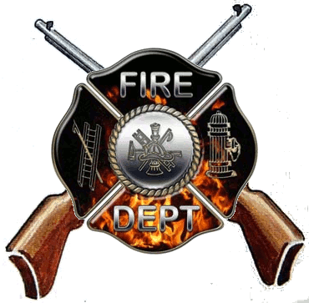
Hampstead
Volunteer Fire Co
Virtual Sportsman Drawing

Due to the COVID pandemic we are unable to hold this event in the traditional way, as a result we have increased the amount of prizes both in guns and cash.

We will be live streaming this event on the Hampstead Volunteer Fire Company Facebook page and winners will be notified by a committee representative within 48 hours of the live drawing.

Drawing to be held virtually – May 22nd @ 11:00 am

Tickets - $35.00 each
Only 350 Tickets will be sold

Prizes:

350 Anderson/BLW - Custom Built AR15
349 Savage Axis 6.5 CR
348 Remington 700 ADL .243
330 $50.00
315 Winchester SXP 12 GA Trap
300 $50.00
285 CVA Accura 50CAL V2 INLINE
270 $50.00
255 Killer Instinct SWAT 408 XBOW
240 $50.00
225 Savage Axis .243 Compact Muddy Girl
210 $50.00
195 Remington 783 7MM
180 $50.00
165 Mossberg Patriot 300WIN
150 $50.00
135 Ruger American Predator 22-250
120 $50.00
105 Henry Golden Boy .22 LR
90 $50.00
75 Mossberg 500 20 GA
60 $50.00
45 Savage 93R17 17 HMR
30 $50.00
15 Ruger American .308
1 $50.00

For ticket info please call – Jaclyn 410.236.8369 or email SportsmanDrawingHvfd@gmail.com
Firearms supplied by: Redding’s Hardware & Sports Goods, 279 S Franklin Street, Gettysburg, PA
(All firearms to be picked up at gun shop after appropriate background checks.
All prizes are Maryland Compliant and must be claimed within 30 days of drawing)

Permit #: 257

